**P2 - Sustainable Supply Chain Performance Dashboard using**

**Power BI**

**WEEK 1 ASSIGNMENT**

**Steps to import and create tables using .CSV for Data Analysis using Power BI**

**Sustainable Supply Chain Performance Dashboard Using Power BI**

**Step 1: Open Power BI and import your CSV file.**

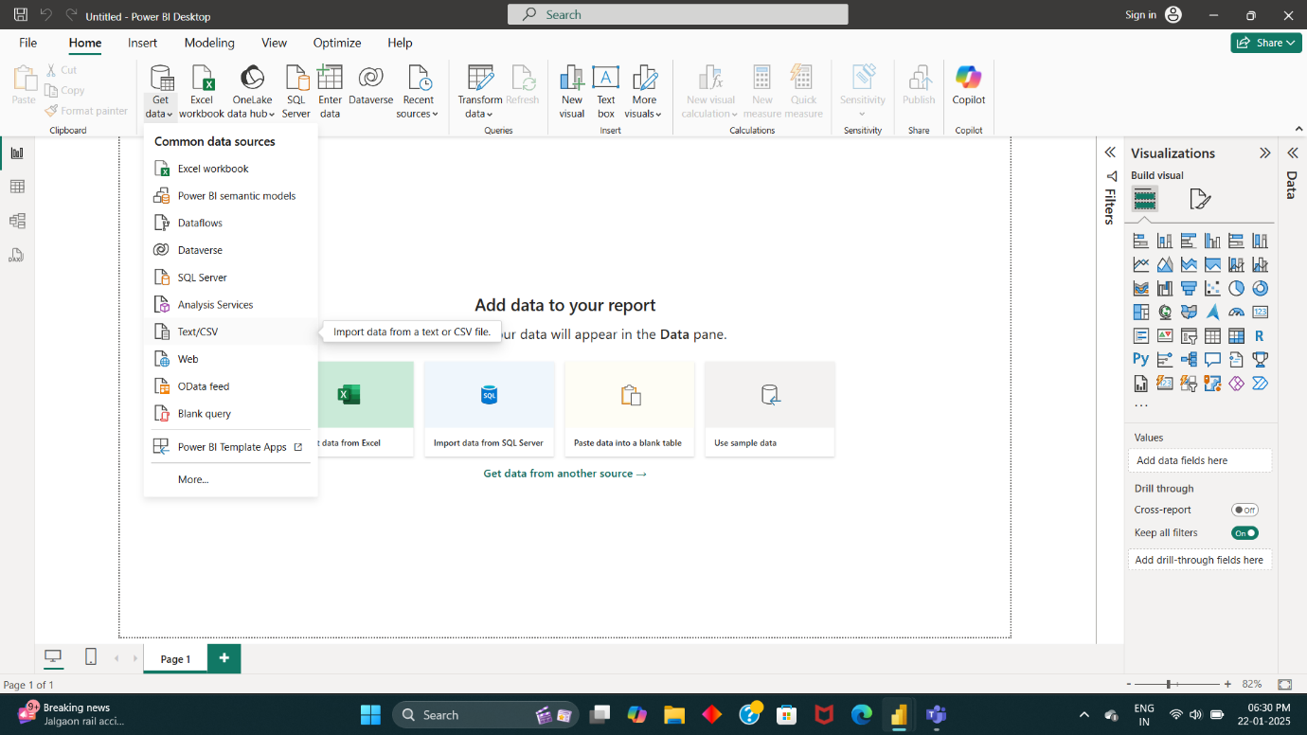

**Step 2: Select the CSV file and click upload.**

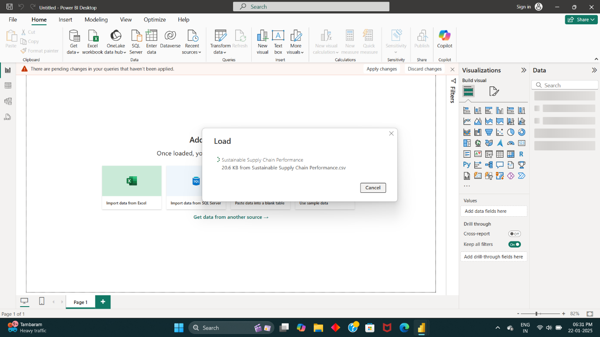

**Step 3: View the imported table in the Data Region on the home page.**

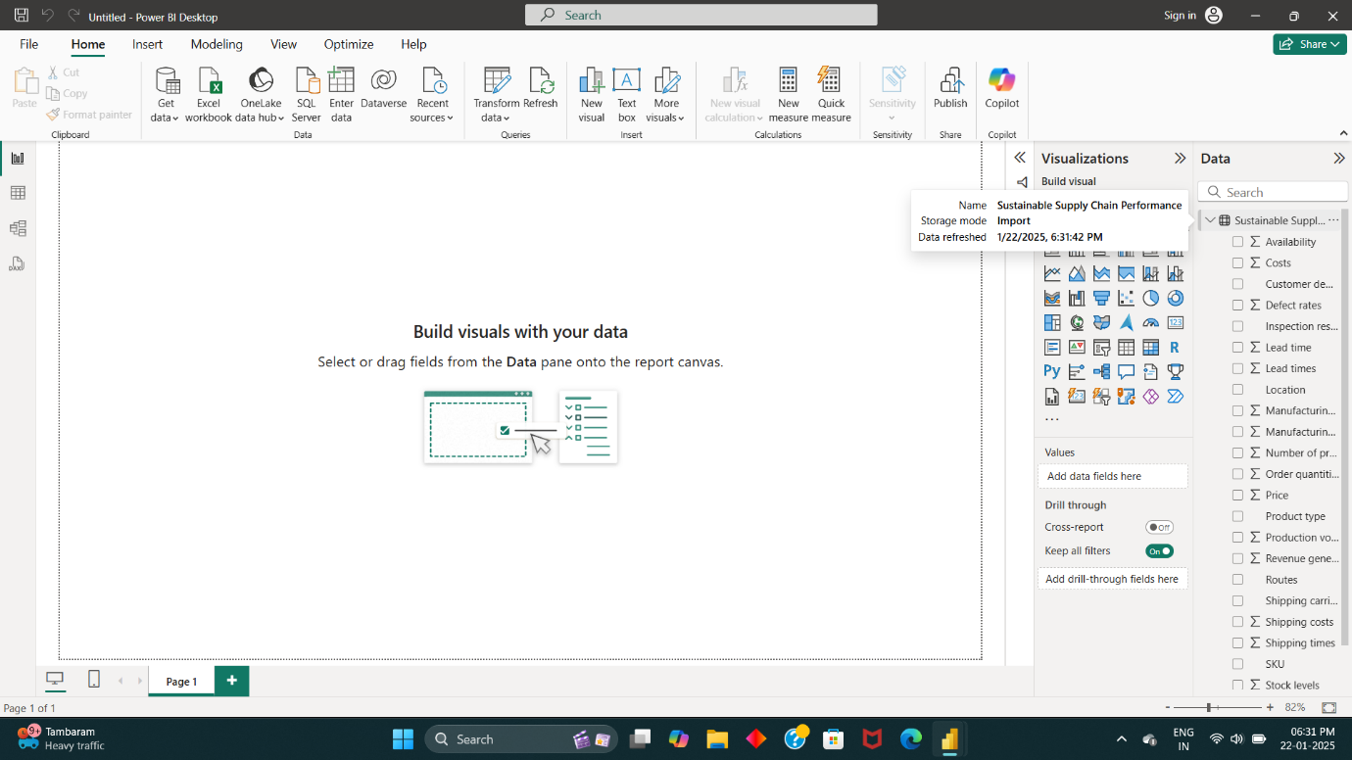

**Step 4: Transform data by navigating to Transform Data and duplicating tables in Power Query Editor.**

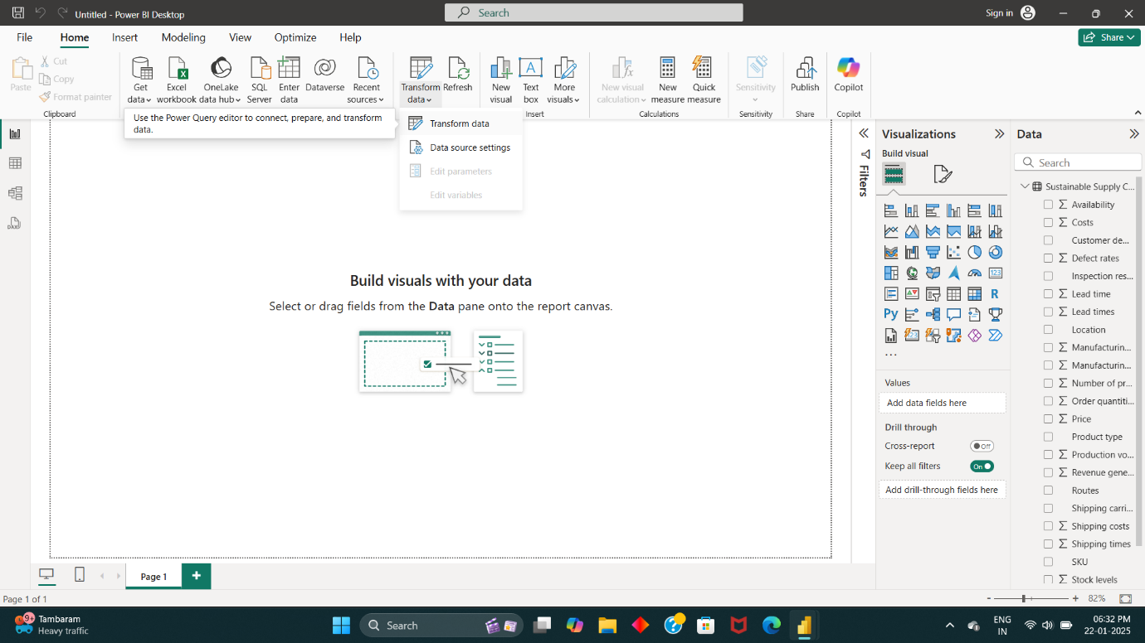

* The Transform Data navigation will redirect to **Power Query Editor** panel
* In Power Query Editor, The Table will be displayed in **Rows and Columns**
* Now In Query region (left-end-side), **Right Click** on the Existing table name and click **Duplicate**

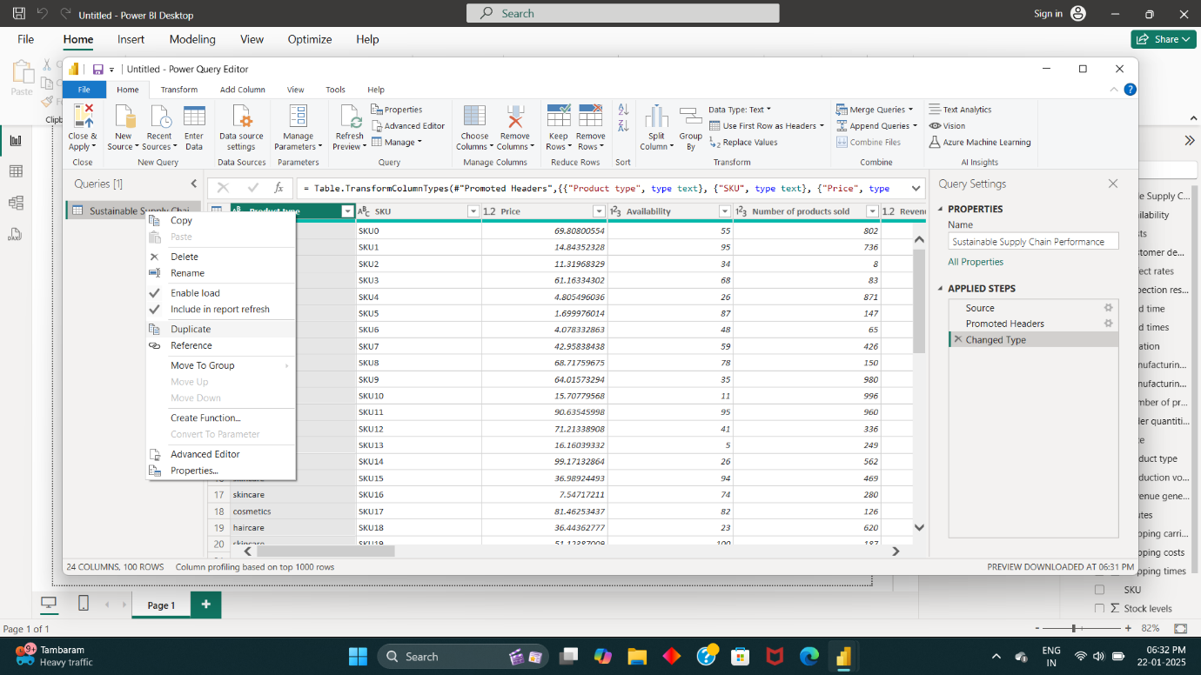

**Step 5: Create tables like manufacturing, supplier, inventory, and supply chain by duplicating and removing irrelevant columns.**

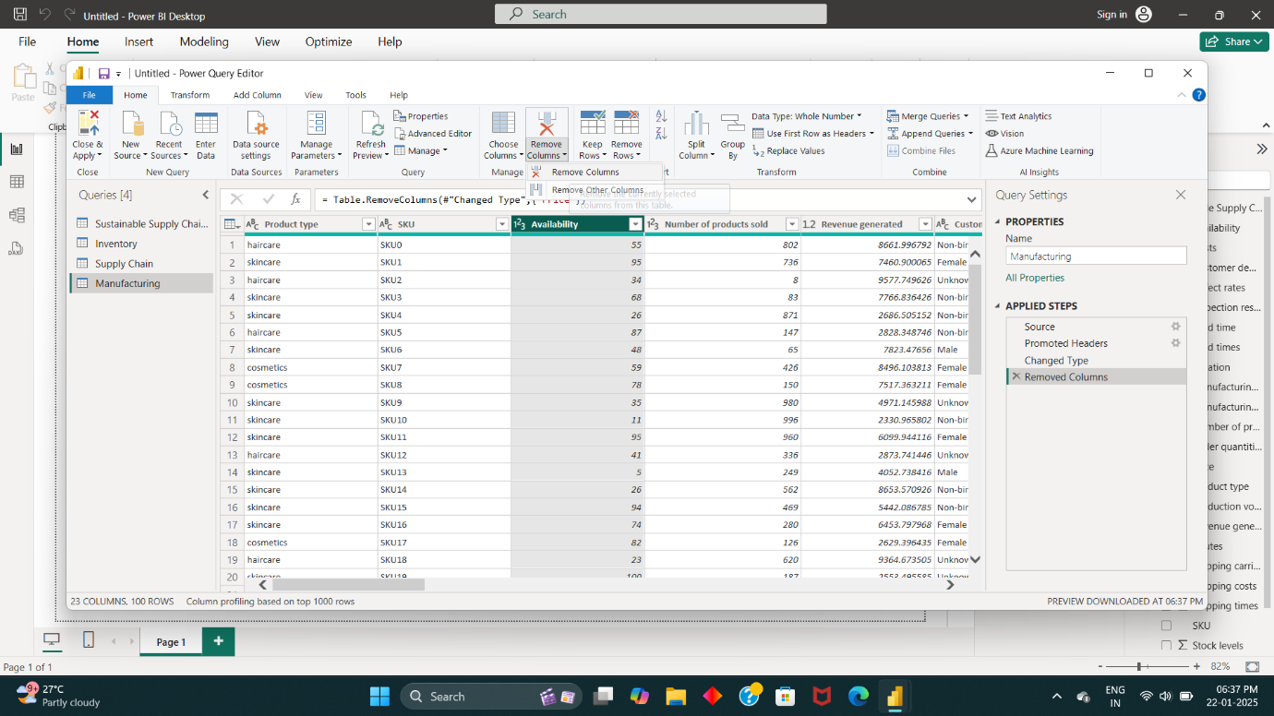

**Step 6: Save the transformed data using the Close & Apply option.**

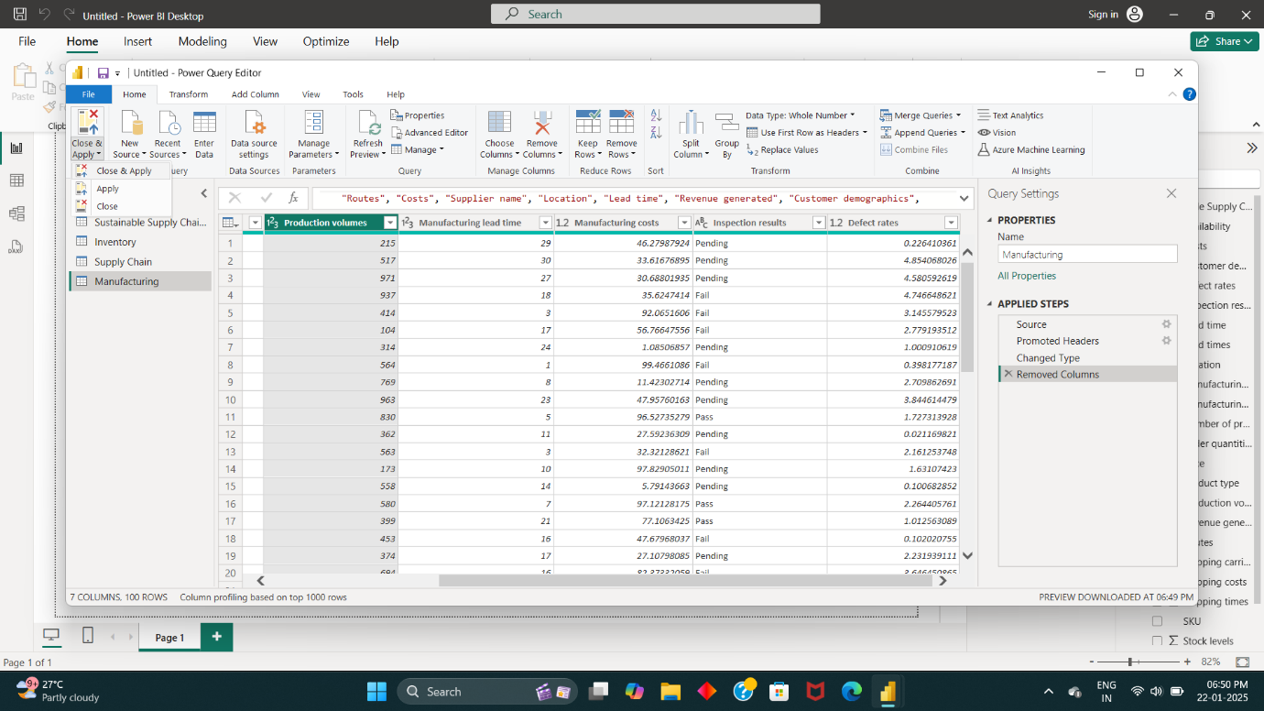

**Step 7: Analyze data and view attribute correlations in Model View.**

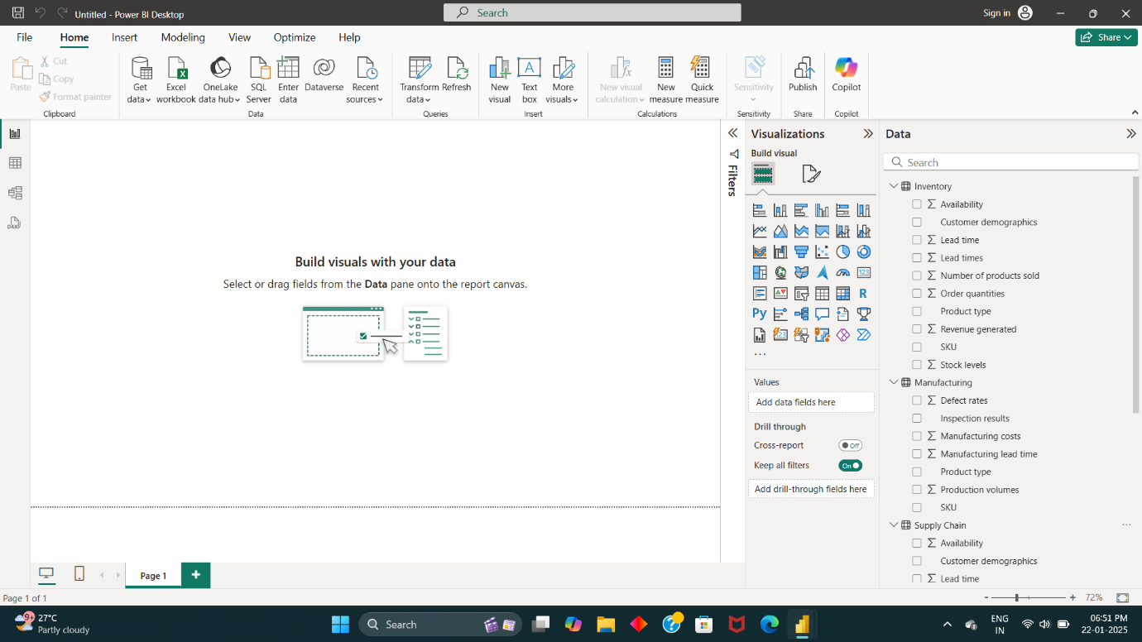

* In **Model View**, we can able to view how each **attribute** correlated to each **tables.**

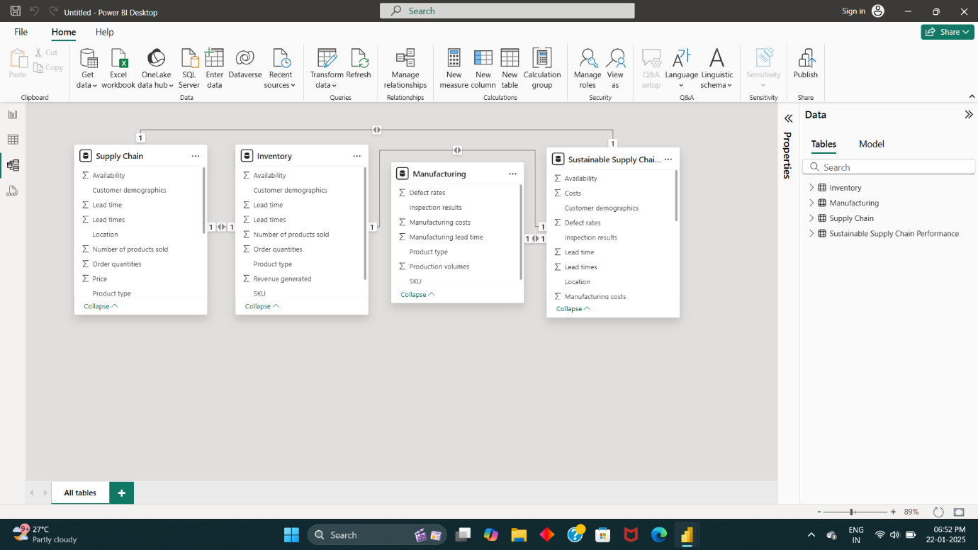

* Thus, the table data is ready to Analysis of Sustainable Supply Chain Performance Dashboard using Power BI.